**Geography April 19th:**

**Starter:**

The core creates the magnetic field through convection and the Coriolis effect.

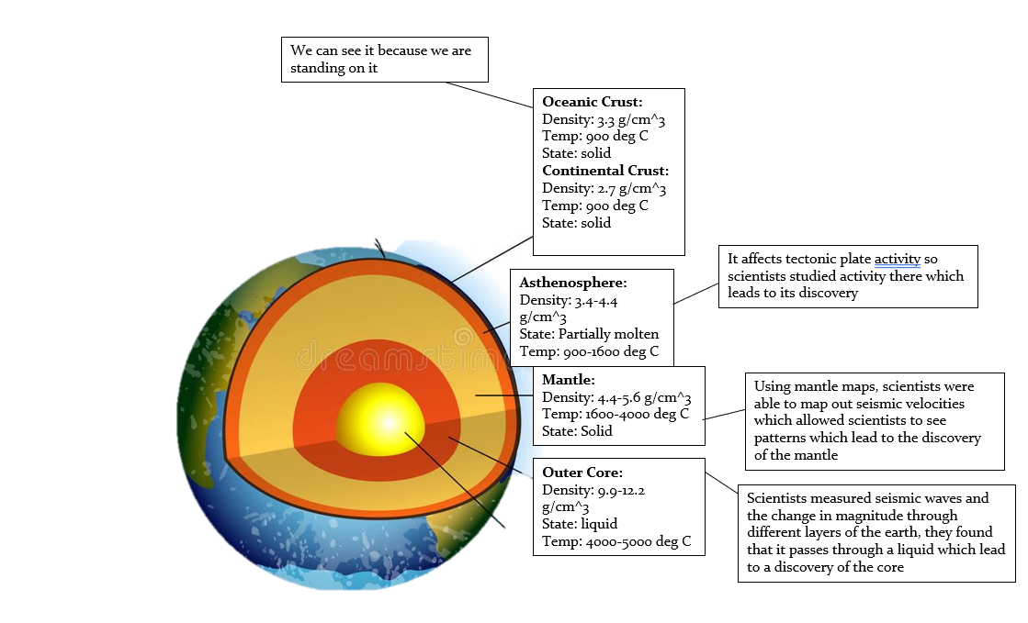

**Question 2:**

|  |  |
| --- | --- |
| **Lithosphere** | **Asthenosphere** |
| Its structure is rigid and brittle, it is divided by tectonic plates | Its structure is solid but some parts consist of molten rock which exhibits plastic properties |
| Seismic waves travel quickly through this | Very dense |
| Composed of 80 elements and approx. 200 minerals | Is constantly under pressure |
| The heat transfer is conductive | The heat transfer is advective |

**Exam question:**

The oceanic crust is primarily composed of mafic rocks while the continental crust is formed by felsic rocks. This is likely because iron and magnesium are abundant in these altitudes (at the bottom of the ocean) while as granite is found at a much higher altitude which allows it to form on the continental crust.